Best Chocolate Cake
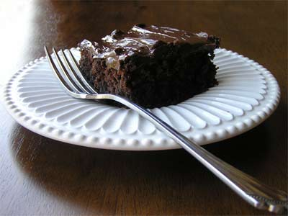
Serves: 12
Ingredients:
2 Cups Flour
2 Cups Sugar
2 teaspoon baking soda
½ teaspoon salt
½ teaspoon baking powder
¾ cup water
¾ cup buttermilk
½ cup shortening
2 eggs
1 teaspoon vanilla extract
4 ounces melted unsweetened chocolate (cooled)

Directions:
Preheat oven to 350°F.
Grease and flour baking pan (9 x 13 or 2 9-inch rounds)
Measure all ingredients in large bowl.
Blend ½ minute on low speed, scraping the bowl constantly. Beat 3 minutes high speed, scraping the bowl constantly. Pour evenly into cakes pans.
Bake oblong pan for 40-45 minutes and layers for 30-35 minutes or until a toothpick inserted in the center comes out clean.
Cool in pan on rack.

